

**Advanced Software Analysis and Design**

**The Virtual Classroom**

**Prepared by:**

**Eman Khaleel AL_Dasoqi**

**Soukena Mohammd AL_Glilat**

**Introduction:**

**Virtual Classroom is a collaborative teaching tool to assist the students to learn in an interactive manner. It aims to complement the efforts of teachers to integrate technology into their classrooms and link the students to the Internet in educationally productive ways and provide them a stimulating, positive and enjoyable environment to study. Our project virtual classroom contains student login and instructor login we they can do some activities such that view course and watch lecture video and manage courses and lectures by instructor user**

**We are using**

* **IDE : Netbeans 8.1**
* **Oracle 11g express edition.**
* **Database: Oracle sql developer**



**The Uml Diagram:**

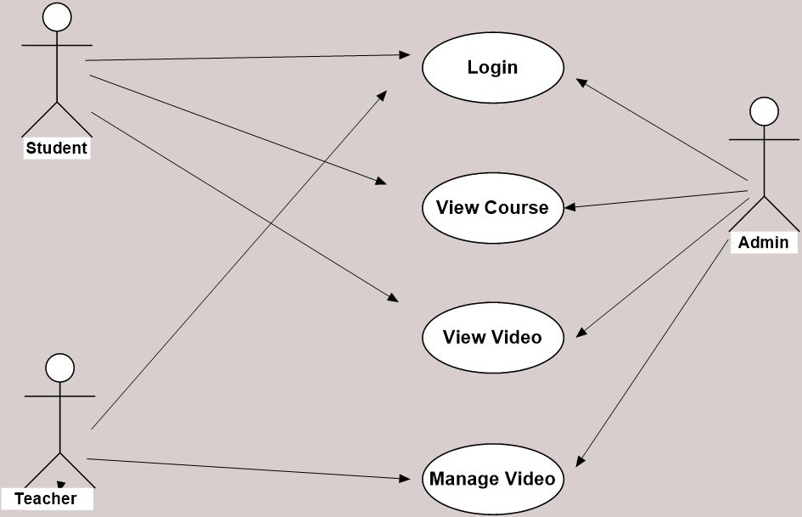 **Fig 1: UML Diagram**

**In Fig1 we can see Our UML diagram its contains three actors (student, instructor , admin ) When student can do login and view course when he can choose the course and then view lectures of course . Instructor can do login and view course and view lecture and manage video. Finally admin actor can manage all activities.**

**User Interface (UI):**

1. 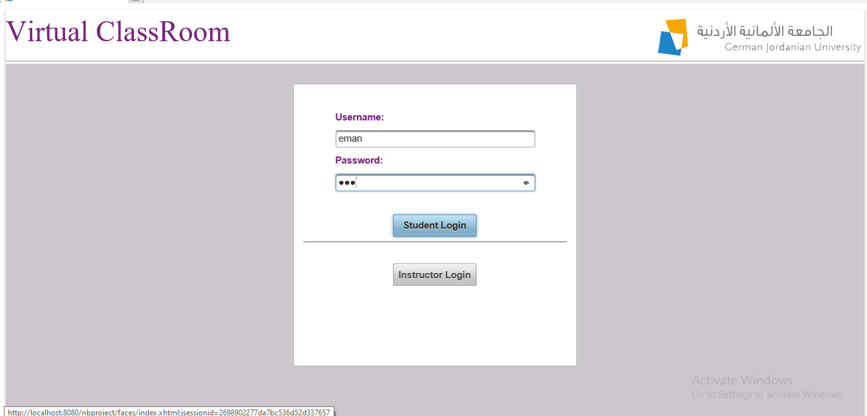**Login page**

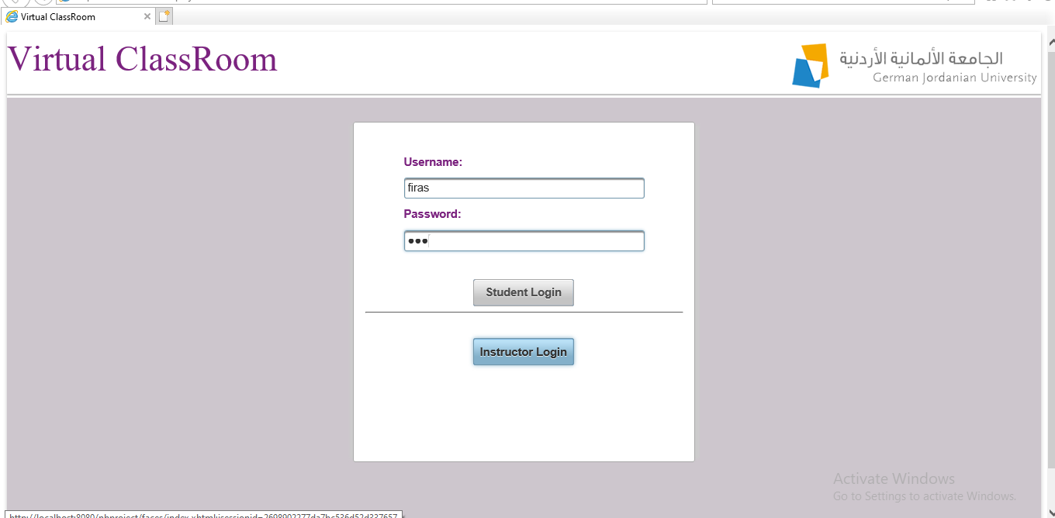

***Fig2 : Login Page .***

**In login page it contains two input text (username ,password ) student and instructor can enter their information After that press into buttons (Command buttons :student login and instructor login)**

1. **Course page**

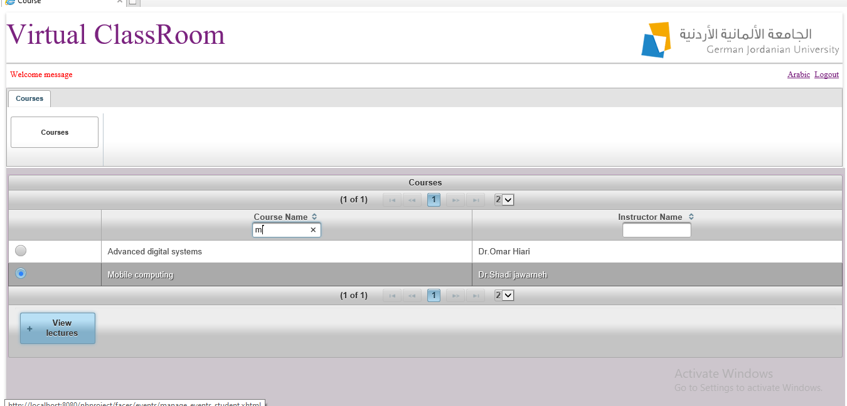

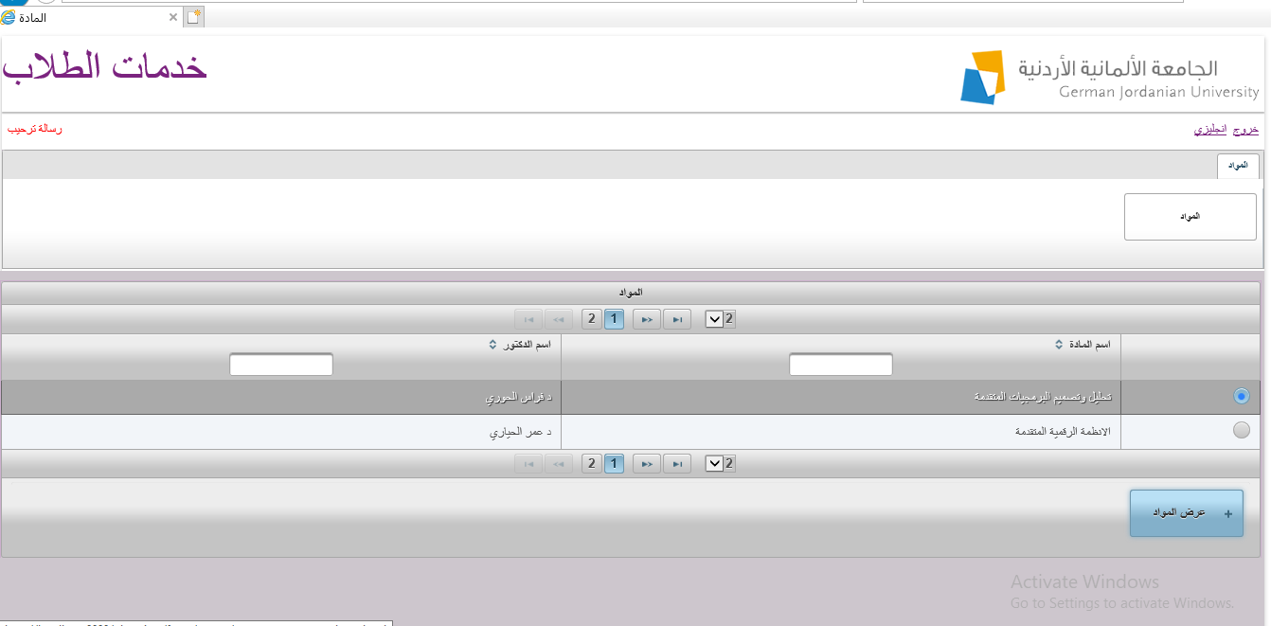

***Fig 3 : Course View***

**In this page view course its contains to table with two filters ( course name and instructor name ) can choose courses through search it by these filters .After that when we choose course by selected radio button and press on view lecture button it open view lecture page .**

1. **Lecture View**

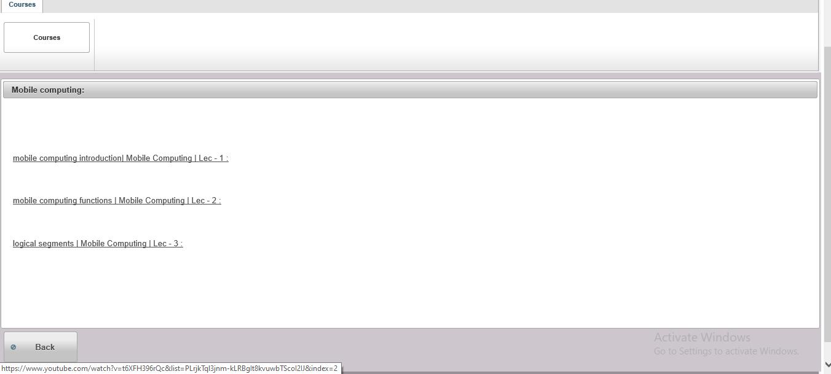 ***Fig 4 : Lecture View***

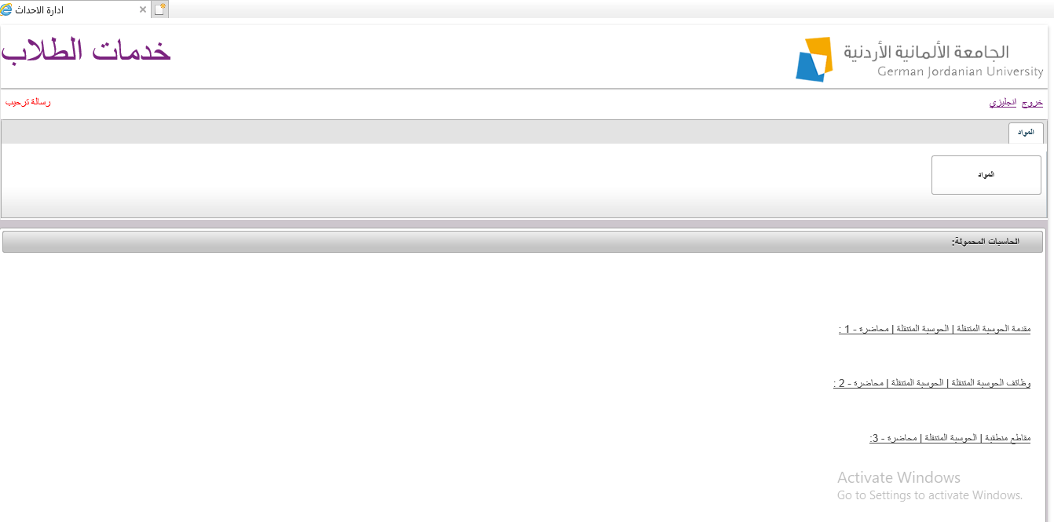

***Fig 5: Lecture View in AR interface***

**In this page we can see all lecture by course we selected in previous page view course here we can press to lecture link and watch video .**

1. 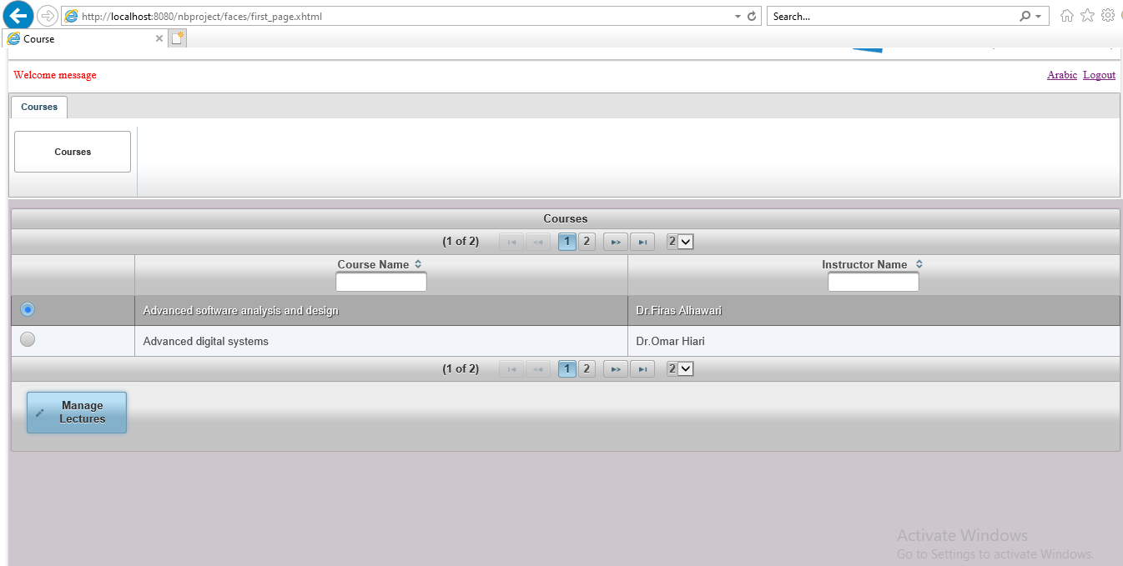**Course page**

***Fig 5: Course View for Instructor***

**In this page after we selected course name and press manage lectures ,it open a new page to manage lectures**

1. **Manage Lectures:**

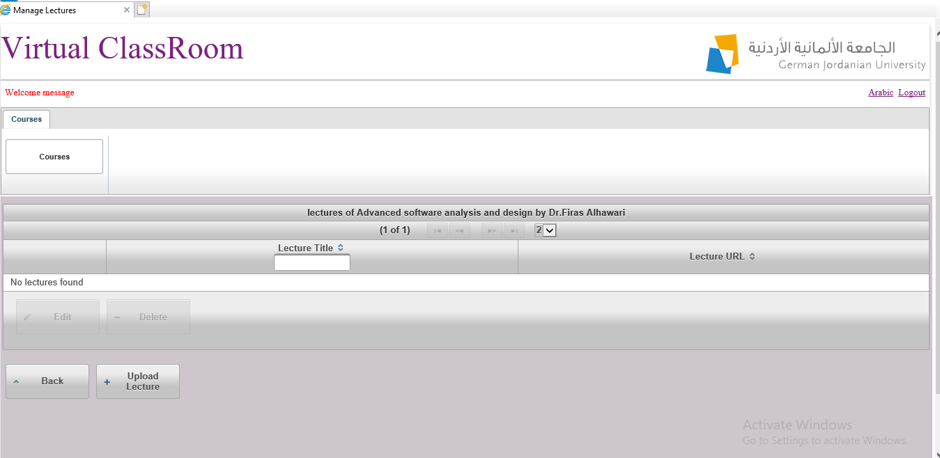

***Fig 7: Lecture View& Manage .***

**In this page we can see table with lecture number filter and Lecture Name and Lecture URL also it contain four buttons**

**Tow buttons using to manage lecture delete and edit lectures**

**Others buttons Back and Upload lecture When we press back button we return to view course page but upload button open new page to add a new lecture.**

1. **Upload lecture**

**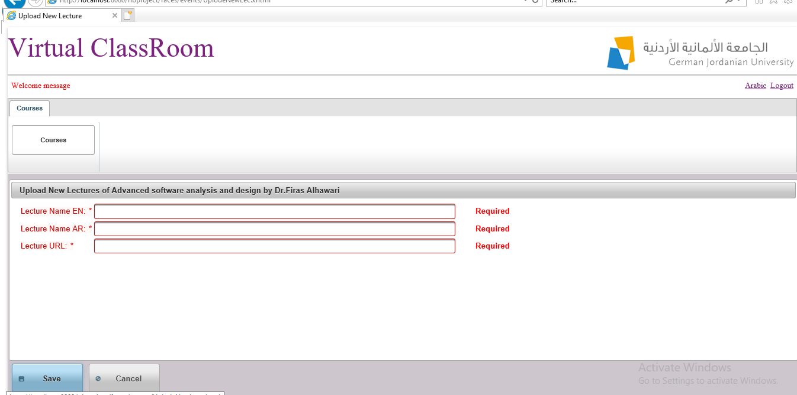 *Fig8 : upload new lecture***

**Here in this page instructor can upload new lecture when he can enter information of lecture (lecture name en and ar , lecture URL ). After that he can press to save button to save new lecture in lecture table in database and show it in lecture view page. When he press into cancel button he return into lecture view page .**

**ER Diagram:**

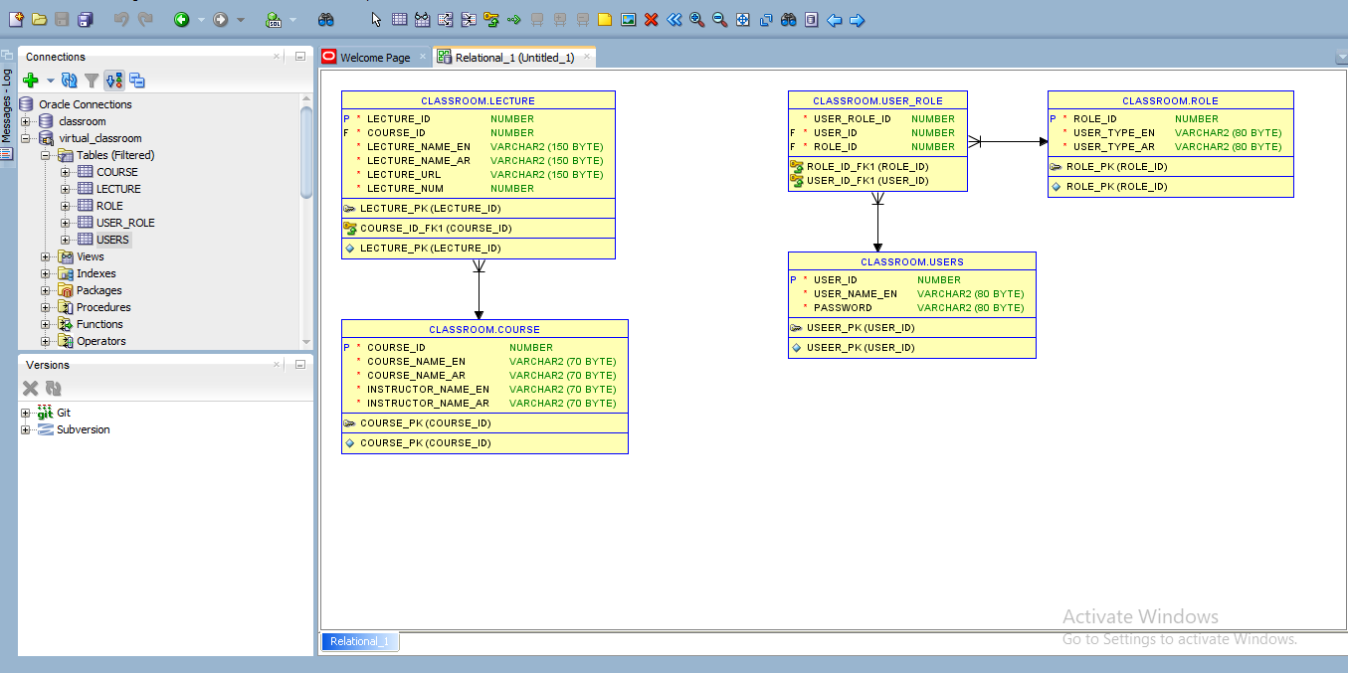

**In this ER diagram we can see tables we created in Oracle SQL Developer .**

**The Tables :**

**Course table contains ( COURSE_ID /COURSE_NAME_EN / COURSE_NAME_AR / INSTRUCTORE _NAME_EN /INSTRUCTORE_NAME_AR) Where course_id primary key .**

**LECTURE table contains ( LECTURE_ID /COURSE_ID /LECTURE_NUM/LECTURE_NAME_EN/LECTURE_NAME_AR / LECTURE_URL) Where LECTURE_ID primary key and COURSE_ID foreign key**

**.**

**ROLE table contains ( ROLE_ID / ROE_TYPE_EN/ROLE_TYPE_AR) Where ROLE_ID primary key /**

**USERS table contains ( USER_ID /USERNAME/PASSWORD )**

**Where USER_ID primary key .**

**USER_ROLE contains (USER_ROLE_ID / USER_ID /ROLE_ID ) Where USER_ID AND ROLE_ID foreign keys**

**List of pages we using in our project :**

**Courses folder contain Jsf File :**

1. **manage_course.xhtml**
2. **manage _courses_student.xhtml**
3. **ManageLectures.xhtml**
4. **LectView.xhtml**
5. **UpdateLecture.xhtml**
6. **First_page.xhtml**
7. **First_page_student.xhtml**
8. **Index.xhtml**

**Bean folder contains :**

**1- LangBean.java**

**2- LecViewBean.java**

**3- ManageLecturesBean.java**

**4- ManageCoursesBean.java**

**5- SessionBean.java**

**6- updateLectureBean.java**

**Daos folder contains :**

1. **ConnectionDao.java**
2. **CoursesDao.java**
3. **LecturesDao.java**
4. **Lectures2Dao.java**

**Models folder contains :**

1. **Course.java**
2. **Lecture.java**